**Starbucks Hot Beverages Cluster**

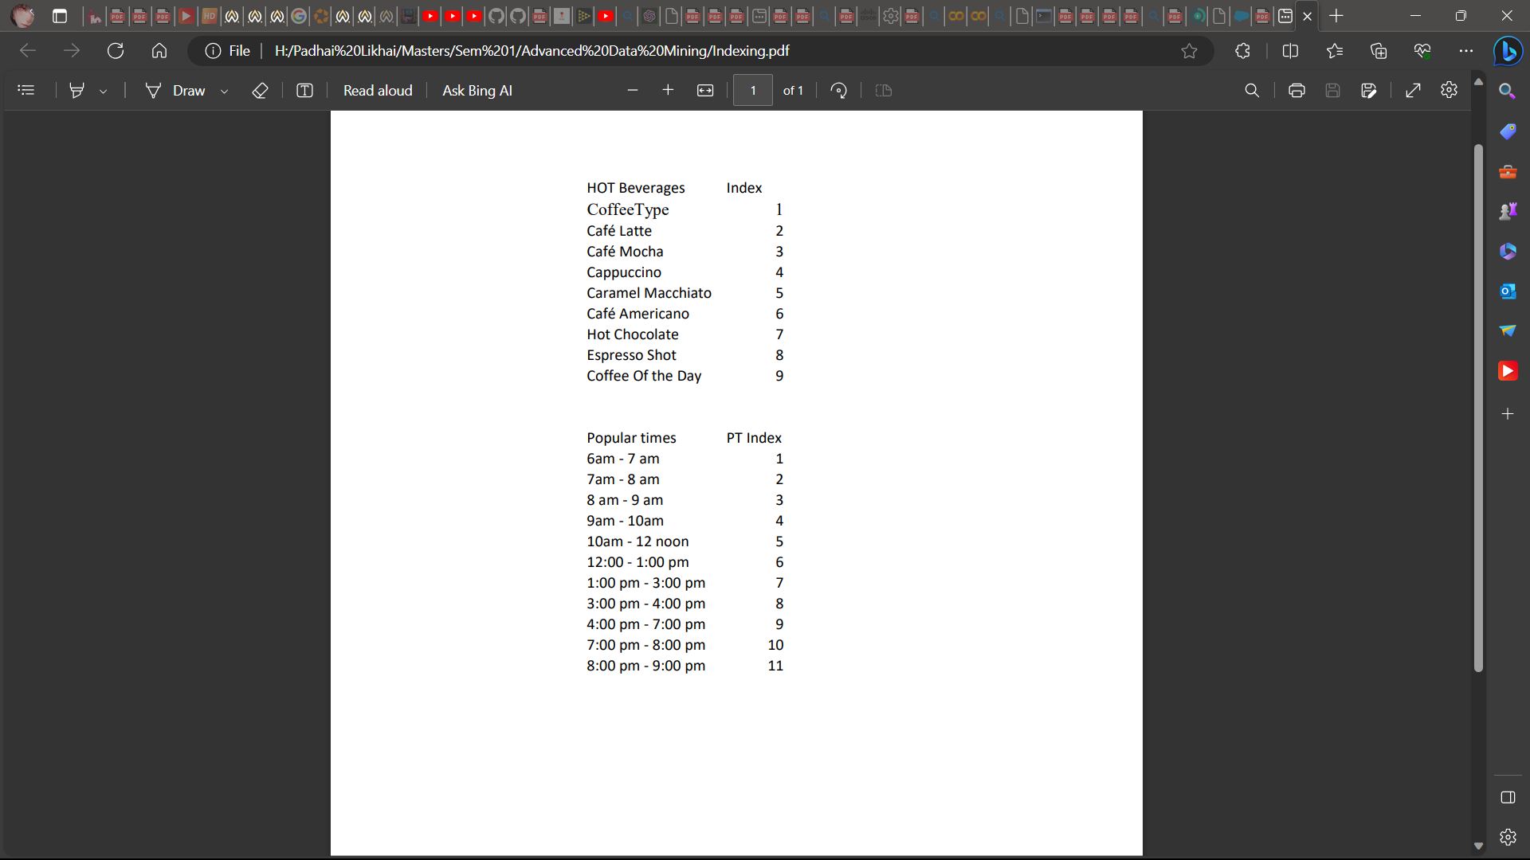 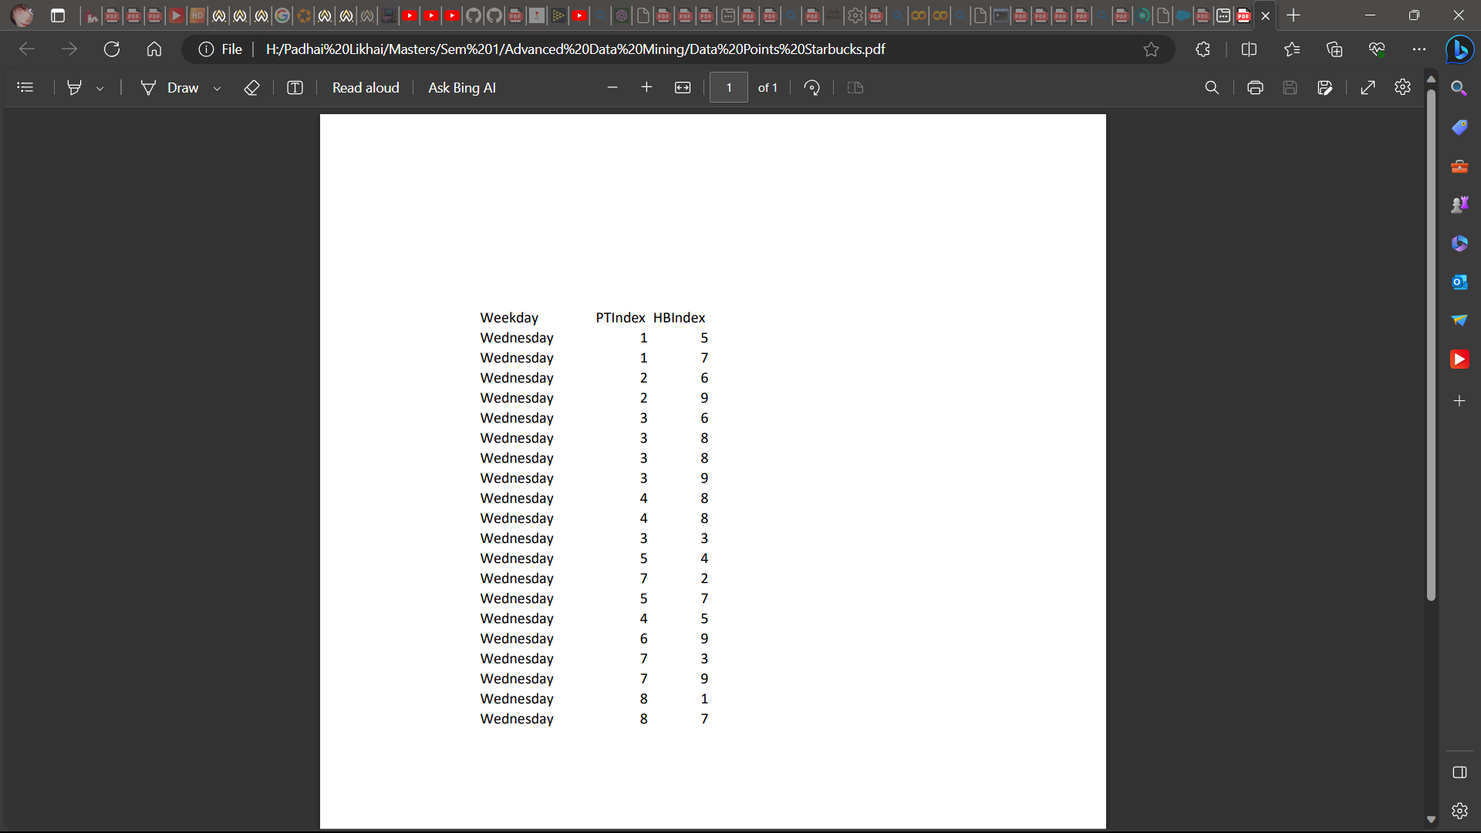

**Indexing Data Points**

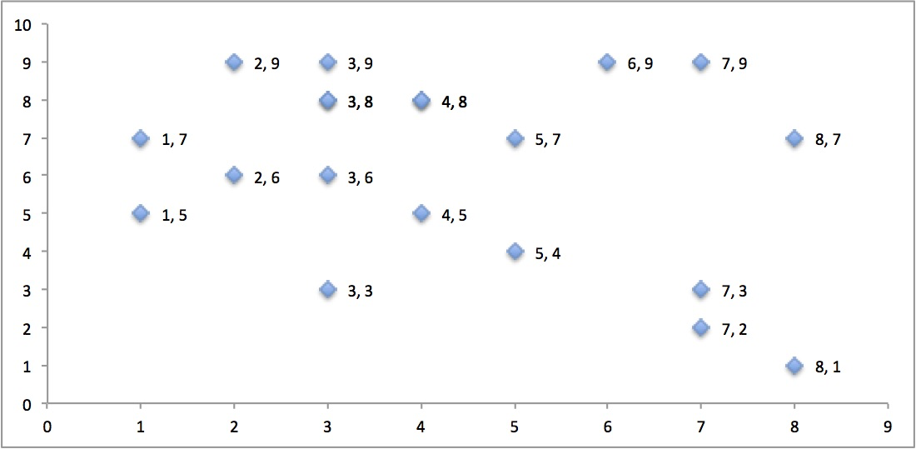

**Hot Beverages vs. Popular Times Data**

**Aim:** To offer sales coupons to customers based on time visit to the store developing cluster (maximum three popular time slots of the day to offer coupon)

**Logic:**

1. Offering Coupons on all Hot Beverages when sales are low.
2. Offering Coupons for Hot Beverages that are sitting at the times of good sales.

**Single Link Agglomerative Clustering**

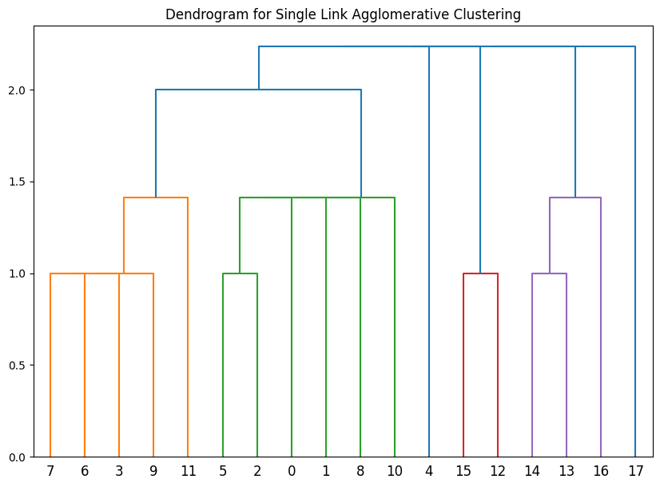

Looking at the dendrogram and with a little trial and error, I decided to cut the dendrogram at level 1.5 which resulted in the following clusters:

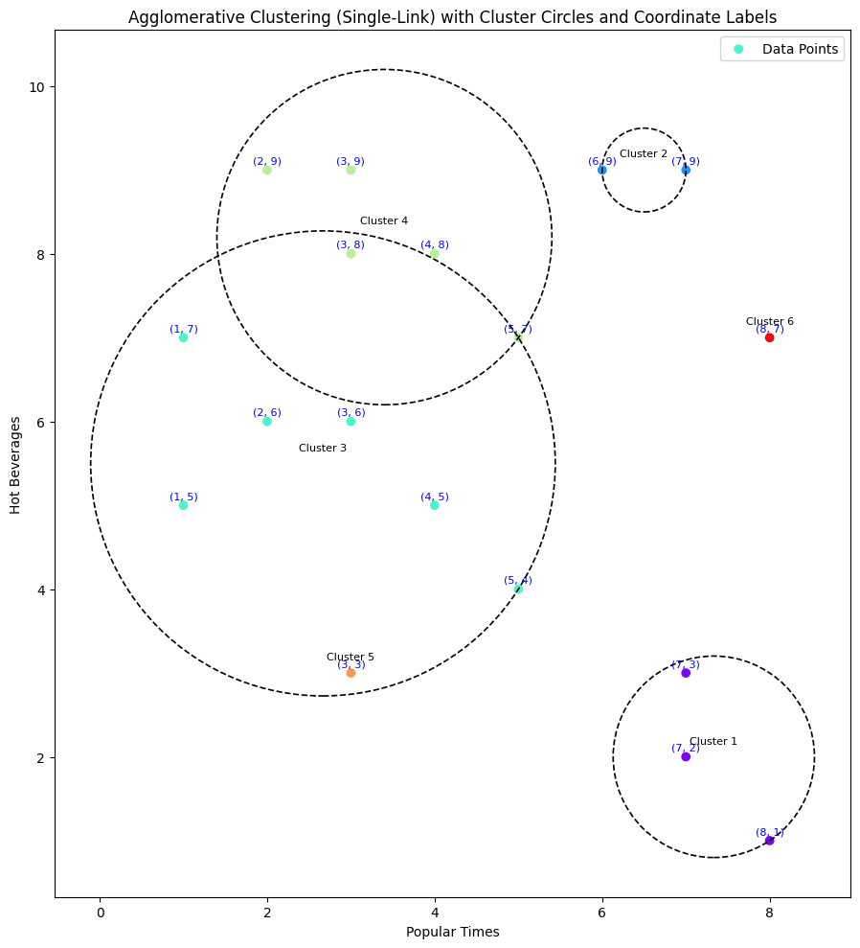

**Observations:**

There are absolutely no customers incoming in 3 consecutive slots:

9: 4 PM - 7 PM, 10: 7 PM – 8 PM, and 11: 8 PM – 9 PM

Sale is limited for Hot Beverages in range 4 to 8, during popular times 6 to 8.

**Coupons:**

On all Hot Beverages for **time slots 9 and 11** (hoping the sandwich i.e. 10 will be taken care of with the help of this arrangement) [Following Logic 1]

On **Hot Beverages indexed 4 to 8,** at **time slot 7.** [Following Logic 2]

**Average Link Agglomerative Clustering**

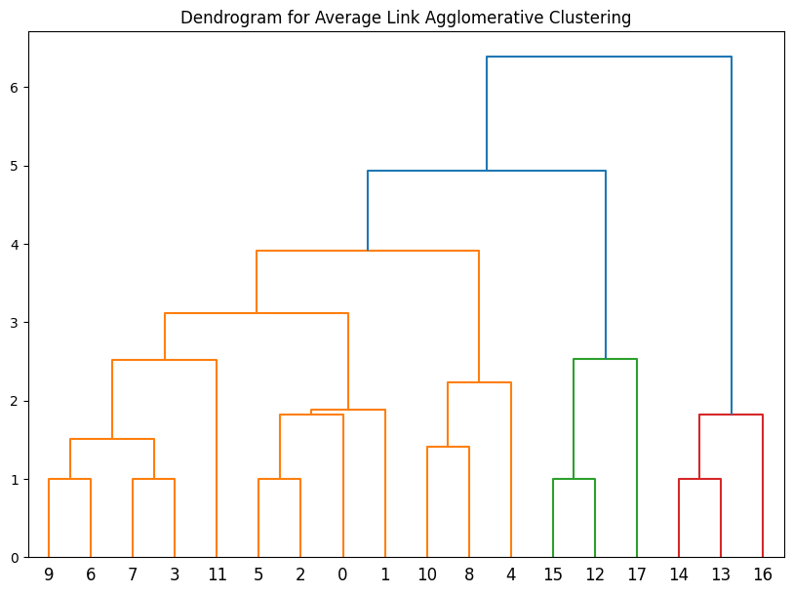

Looking at the dendrogram and with a little trial and error, I decided to cut the dendrogram at level 3.

**Observations:**

There are absolutely no customers incoming in 3 consecutive slots:

9: 4 PM - 7 PM, 10: 7 PM – 8 PM, and 11: 8 PM – 9 PM

Sale is limited for Hot Beverages in range 4 to 6; during popular times 6 to 8.

Starting of the day isn’t solid as only Hot Beverages from 5 to 7 are sold.

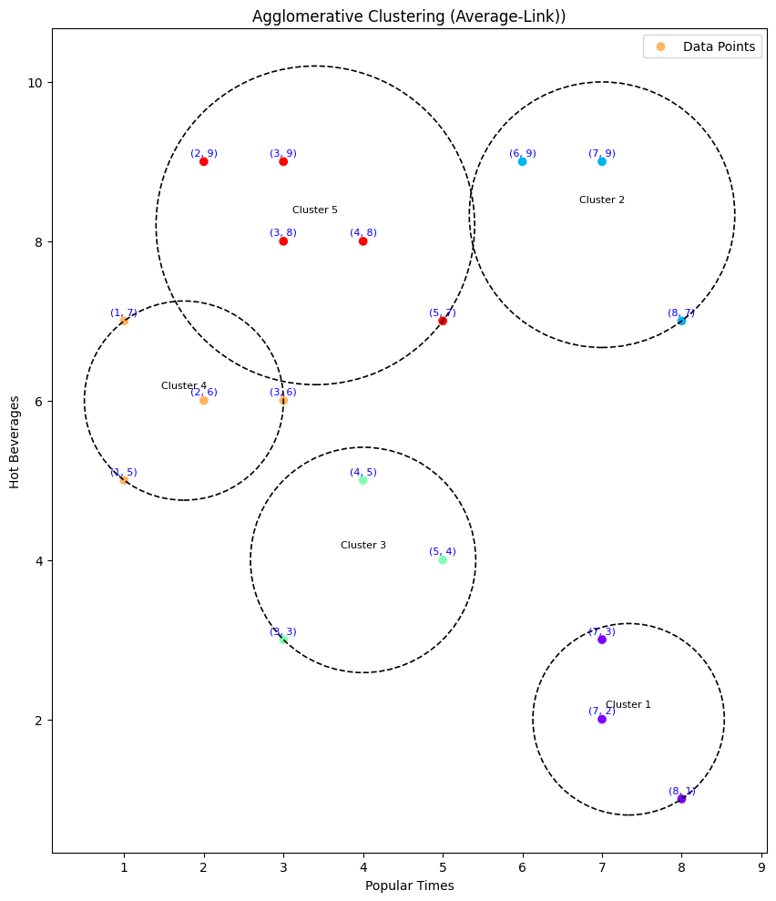

**Coupons:**

On all Hot Beverages at **time slots 9** (hoping the rush would take care of time slot 10 and time slot 11) [Following Logic 1]

On **Hot Beverages indexed 1 to 4 and (8, 9),** at **time slot 1.** [Following Logic 2 and Logic 1 both]

On **Hot Beverages indexed 4 to 6,** at **time slot 7.** [Following Logic 2]

**Complete Link Agglomerative Clustering**

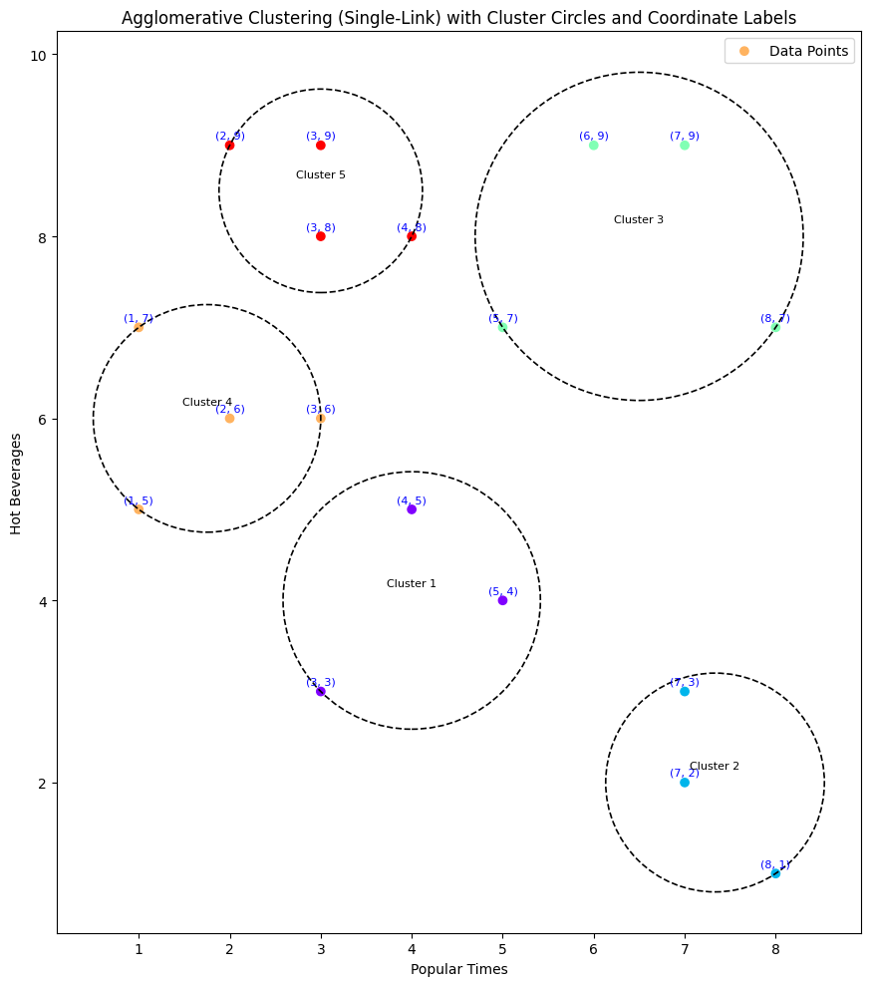

Looking at the dendrogram and with a little trial and error, I decided to cut the dendrogram at level 4.

**Observations:**

There are absolutely no customers incoming in 3 consecutive slots:

9: 4 PM - 7 PM, 10: 7 PM – 8 PM, and 11: 8 PM – 9 PM

Sale is limited for Hot Beverages in range 4 to 6; during popular times 6 to 8.

Starting of the day isn’t solid as only Hot Beverages from 5 to 7 are sold.

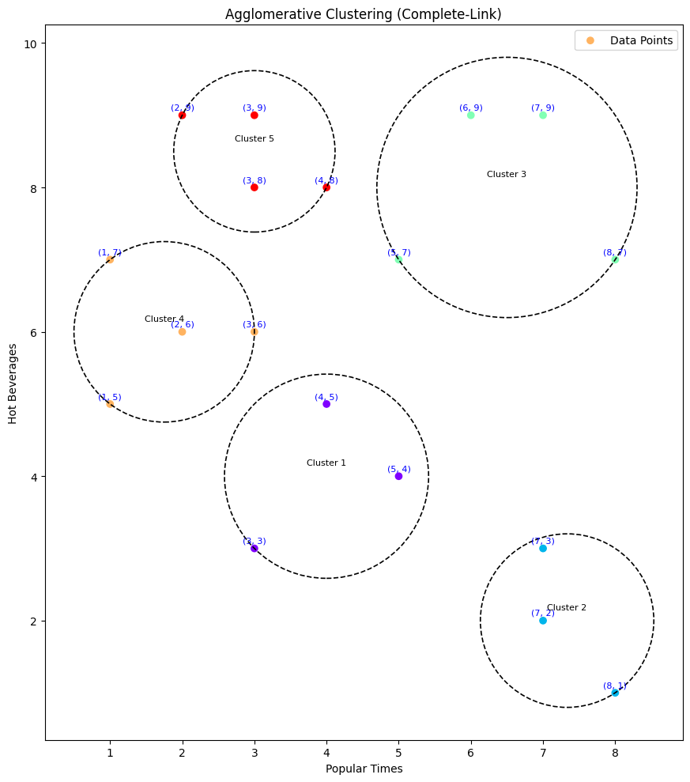

**Coupons:**

On all Hot Beverages at **time slots 9** (hoping the rush would take care of time slot 10 and time slot 11) [Following Logic 1]

On **Hot Beverages indexed 1 to 4 and (8, 9),** at **time slot 1.** [Following Logic 2 and Logic 1 both]

On **Hot Beverages indexed 4 to 6,** at **time slot 7.** [Following Logic 2]